- T-test
Calculations of the mean, sample standard deviation, and a t-test
Inches (x) | x-mean | (x-mean)²
27.87 | -0.76 | 0.5776
29.49 | 0.86 | 0.7396
28.34 | -0.29 | 0.0841
28.20 | -0.43 | 0.1849
29.00 | 0.37 | 0.1369
29.56 | 0.93 | 0.8649
27.95 | -0.68 | 0.4624
Mean = 28.63 |  | Total = 3.0504
n = 7
df = (n-1) = 6
mean = 28.63
Standard deviation = √[∑(x-mean)²/7] =√ [3.0504/7] = 0.713
t value = (sample mean – population mean)/ standard error
standard error = standard deviation/√n = 0.713/√7 = 0.269
t value = (28.63-29.55)/0.269 = -3.42
From t-distribution, t critical value = 2.447
At the two-tailed p-value of 0.05, the t-statistic (-3.42) falls on the rejection region of the t-critical value (2.447), which implies the rejection of the null hypothesis. Hypothesis testing means that the sample mean (M = 28.63) is statistically significantly different from the population mean (M = 29.55).
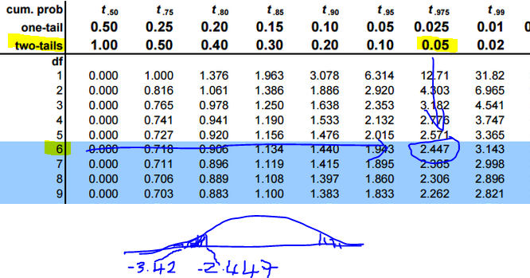
Engineers were correct in their assumption because the sample mean (28.63) is less than the population mean (29.55).

